KL01 - KL01 Create Activity type

Functionality

Activity types describe activities produced by a cost center. They are measured in units of time or quantity. Activity quantities are valuated using a price.
For example: the maintenance department provides maintenance service at a labor hourly rate of USD 100.
When the activities produced by a cost center are used by other cost centers, orders or projects, this means that the resources of the sending cost center are being used by the receiver objects.
By recording the planned and actual quantities consumed, you reallocate cost incurred on the sender into the receivers.
Activity Types can be grouped to facilitate reporting and cost allocation.

Activity types are used to allocate machine cost from production cost center to the production orders.

Scenario
This transaction is used to create an activity type for production hours.

Requirements
None.

Menu Path | Accounting → Controlling → Cost Center Accounting → Master Data → Activity Type → Individual Processing → KL01 - Create
Transaction Code | KL01

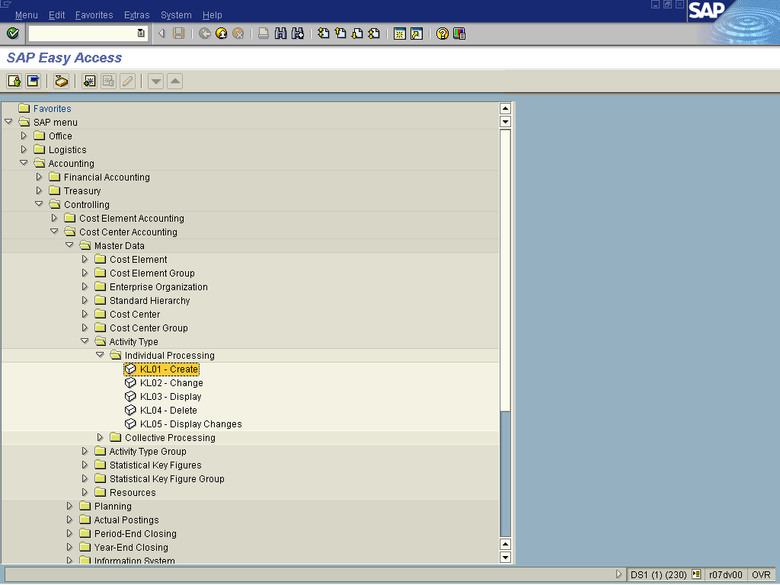

1. Double Click on KL01 - Create

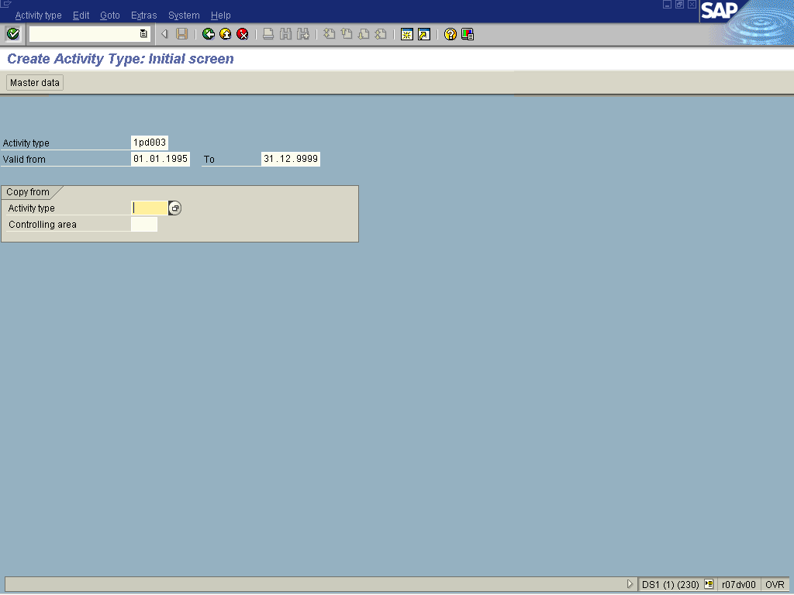

2. Update the following fields:

Field Name | Field Description | Values
Activity type | Activity types describe the activity produced by a cost center and are measured in units of time or quantity. | Example: 1pd00
Valid from | Valid from date field | Example: 01.01.1995
To | Valid to date field | Example: 31.12.9999

3. Click Enter

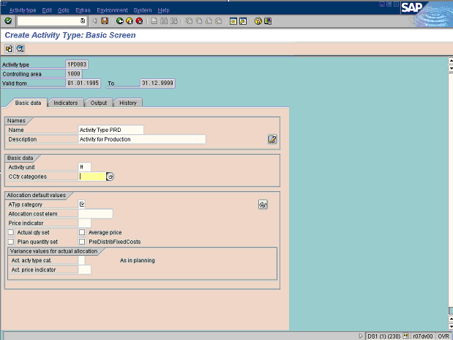

4. Update the following fields:

Field Name | Field Description | Values
Name | Description of the Name. | Example: Activity Type PRD
Description | Brief text description of the run schedule | Example: Activity for Production
Activity unit | Description of the Activity unit. | Example: H

5. Click CCtr categories Button .

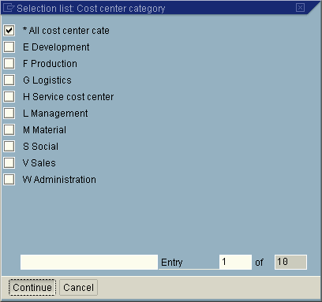

Note: Indicator determining for which cost center types an activity type is allowed for planning and as a sender in internal activity allocation.

6. Make your selection by clicking on the <checkbox> .
7. Click Continue Button .
8. Click Activity Type Category Button .

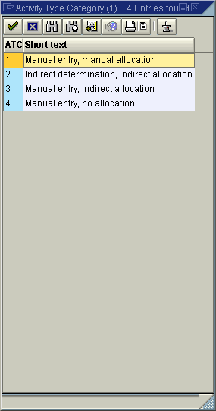

Note: Indicator determining the method of activity quantity planning and activity allocation.
9. Select 1 - Manual entry, manual allocation in list box.

10. Update the following fields:

Field Name | Field Description | Values
Allocation cost element | The allocation cost element is a secondary cost element , under which the activity type or business process is allocated. | Example: 943002

11. Click Price indicator Button .

Price indicator (1) 3 Entries found

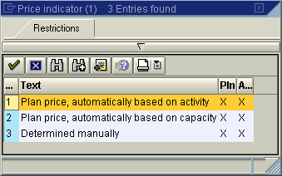
12. Select 3 - Determined manually

Note: Indicator showing how SAP calculates the price of a business process or activity type for a cost center..

13. Click <checkbox> Average price . Indicator determining that activity prices for cost centers/activity types remain constant for the entire fiscal year.
14. Click the Enter button.
15. Click <tab button> Indicators .

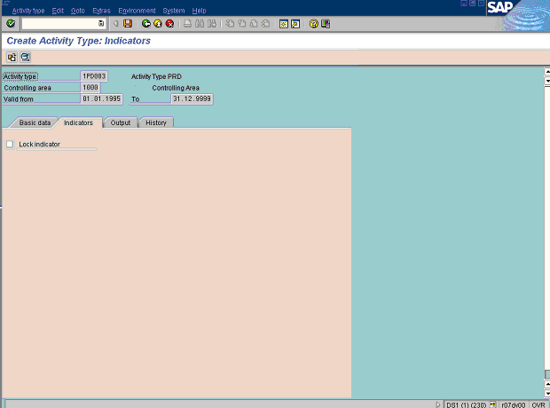

Note: This screen controls activity type locking.
16. Click the Enter button.
17. Click <tab button> Output .

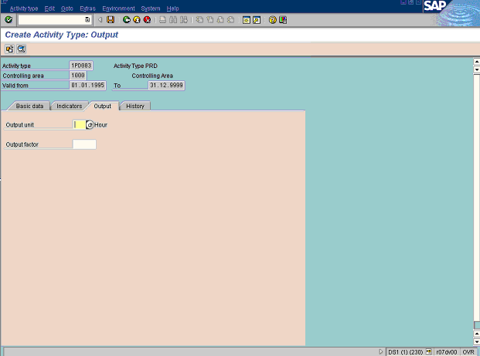

Note: There are no required fields to be entered.

18. Click the Enter button.

19. Click Save

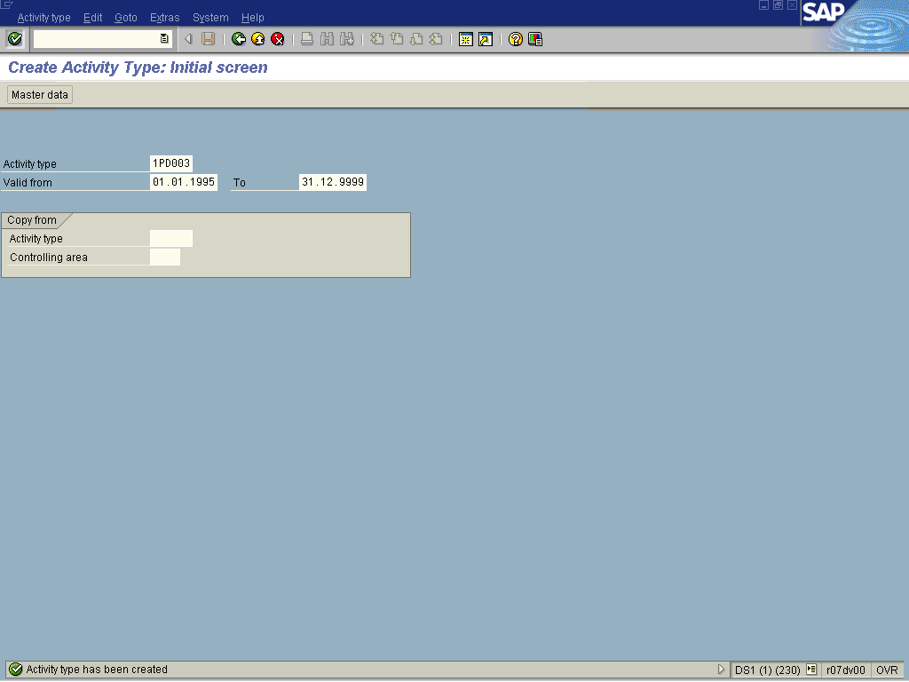

20. The message bar displays “Activity has been created”

